Year Group: Nursery Teacher: Mr McConnell Class: NMMcC Week Beginning: 29.03.2021
 |  |  | 9.15 – 10.00 | 10.30 – 11.30 |  | 1.00 – 2.00 | 2.00 – 3.00
Monday | Good morning everyone. Please use this timetable to help you through daily activities.  We have just introduced our new app called ‘Tapestry”. Please send in pictures of completed work through the tapestry app!  Start your morning with a nice healthy snack and drink.  Which healthy snack are you going to choose today?  Can you tell your parent/carer what it looks like and tastes like? | Break | Nursery rhyme time  Sing some of your favourite nursery rhymes with a family member. You could take it in turns suggesting which nursery rhymes you would like to sing next.  You could always line up your toys and pretend that you are the teacher. You could sing to your toys. | Easter egg decoration  Can you create your own Easter egg pattern at home? All you will need is a template of an egg and some pencils/pens. If you have any paints at home, you could also use these to create a pattern.  Here are some pattern ideas..  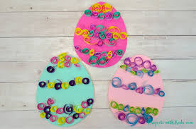 | Lunchtime | Andy’s wild workout  See if you can join in with Andy’s wild workout!  https://www.bbc.co.uk/iplayer/episode/p06tmry2/andys-wild-workouts-series-1-9-the-undergrowth | Read your favourite story with your parent/carer.
Tuesday | Good morning everyone. Please use this timetable to help you through daily activities.  We have just introduced our new app called ‘Tapestry”. Please send in pictures of completed work through the tapestry app!  Start your morning with a nice healthy snack and drink.  Which healthy snack are you going to choose today?  Can you tell your parent/carer what it looks like and tastes like? |  | Egg and spoon race  Can you balance an egg onto a spoon and walk across the room? Remember to put one arm behind your back or to the side so you cannot cheat!  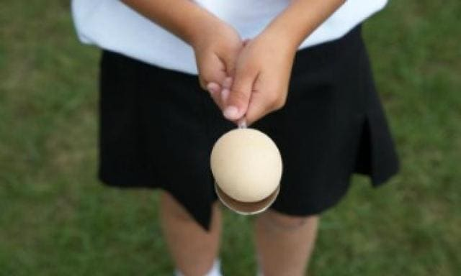  You could hold your own egg and spoon race competition in your household, to see who the egg and spoon race champion is! | Number Time  Sing along to the song all about the number ‘10’.  https://www.youtube.com/watch?v=0zVLWGaLi7g  Watch along with Numberblocks  https://www.youtube.com/watch?v=k4i6fu0bTQ8  Go on a number hunt around your house.  Can you find anything with the number 10 on it?  Can you find 10 of something?  What number comes after the number 10?  Take a picture and send it into Tapestry! |  | Yoga Time  Join in with spring yoga!  https://www.youtube.com/watch?v=ASPnHl7kio4 | Read your favourite story with your parent/carer.
Wednesday | Good morning everyone. Please use this timetable to help you through daily activities.  We have just introduced our new app called ‘Tapestry”. Please send in pictures of completed work through the tapestry app!  Start your morning with a nice healthy snack and drink.  Which healthy snack are you going to choose today?  Can you tell your parent/carer what it looks like and tastes like? |  | We’re going on an egg hunt  Listen to the story ‘We’re going on an egg hunt’.  Can you think of another story which this sounds like?  https://www.youtube.com/watch?v=Q35GN23ZFzM | Egg hunt  If you have any chocolate eggs or Easter toys in your household, ask a family member to hide them around your house. Can you find all the items which have been hidden?  How many items have been hidden? Can you count them all? |  | Numberblock game  Play along with the interactive number block game  https://www.bbc.co.uk/cbeebies/games/numberblocks-make-and-play?collection=fun-activities-for-toddlers-and-preschoolers | Easter picture  Can you create your own Easter picture? Think about things which are associated with Easter and how you could include them in your picture.  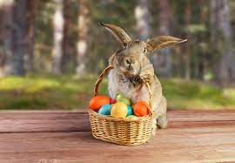  Here are some pictures which could help.
Thursday | Good morning everyone. Please use this timetable to help you through daily activities.  We have just introduced our new app called ‘Tapestry”. Please send in pictures of completed work through the tapestry app!  Start your morning with a nice healthy snack and drink.  Which healthy snack are you going to choose today?  Can you tell your parent/carer what it looks like and tastes like? |  | Easter Prayer  Begin the day by saying this Easter Prayer.  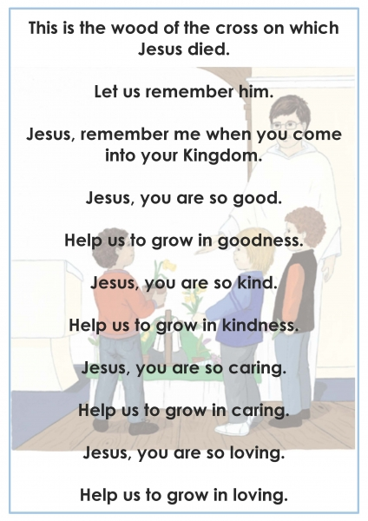 | Sink or float?  If you have any plastic Easter eggs, fill them with different objects. Once your eggs are filled, make a prediction about whether the eggs will float or sink in water.  Place your eggs in water and see if your prediction was right!  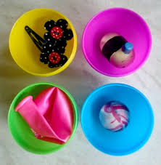 |  | Dough Disco  If you have some playdough at home, you can use this to join in with the ‘dough disco’ activity. If you don’t have any playdough, you could always use others objects such as a sponge.  https://www.youtube.com/watch?v=o9D5lfqZF3o | Good and bad choices  With a family member, think about good and bad choices which we make every day. Can you think of 3 good choices? Now think of 3 bad choices.  Why is it better to make good choices rather than bad choices?
Friday | Good morning everyone. Please use this timetable to help you through daily activities.  We have just introduced our new app called ‘Tapestry”. Please send in pictures of completed work through the tapestry app!  Start your morning with a nice healthy snack and drink.  Which healthy snack are you going to choose today?  Can you tell your parent/carer what it looks like and tastes like?

