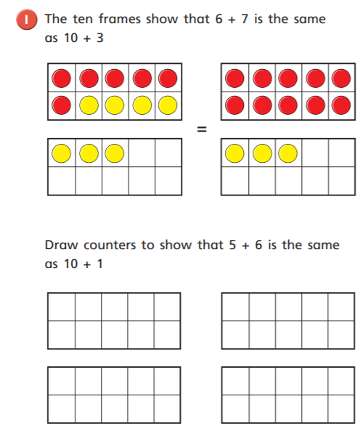

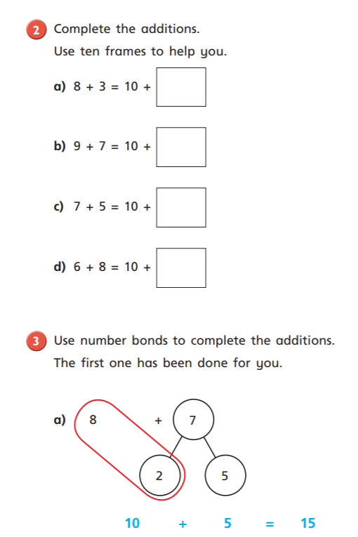

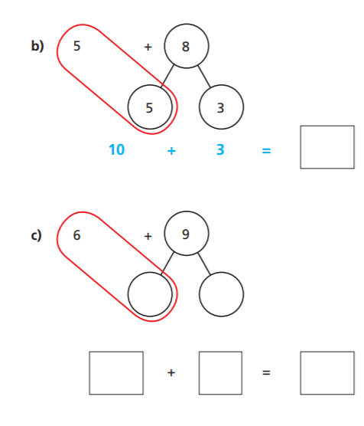

Reasoning and Problem Solving

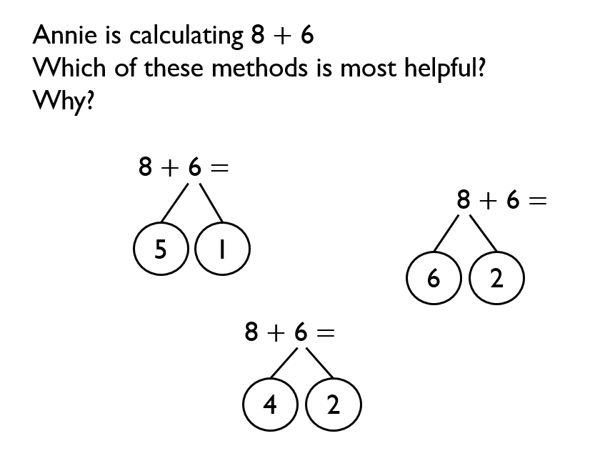

I think ………………………………………………………………. Is most useful.

I think this because……………………………………………………………………

………………………………………………………………………………………………………..

………………………………………………………………………………………………………….