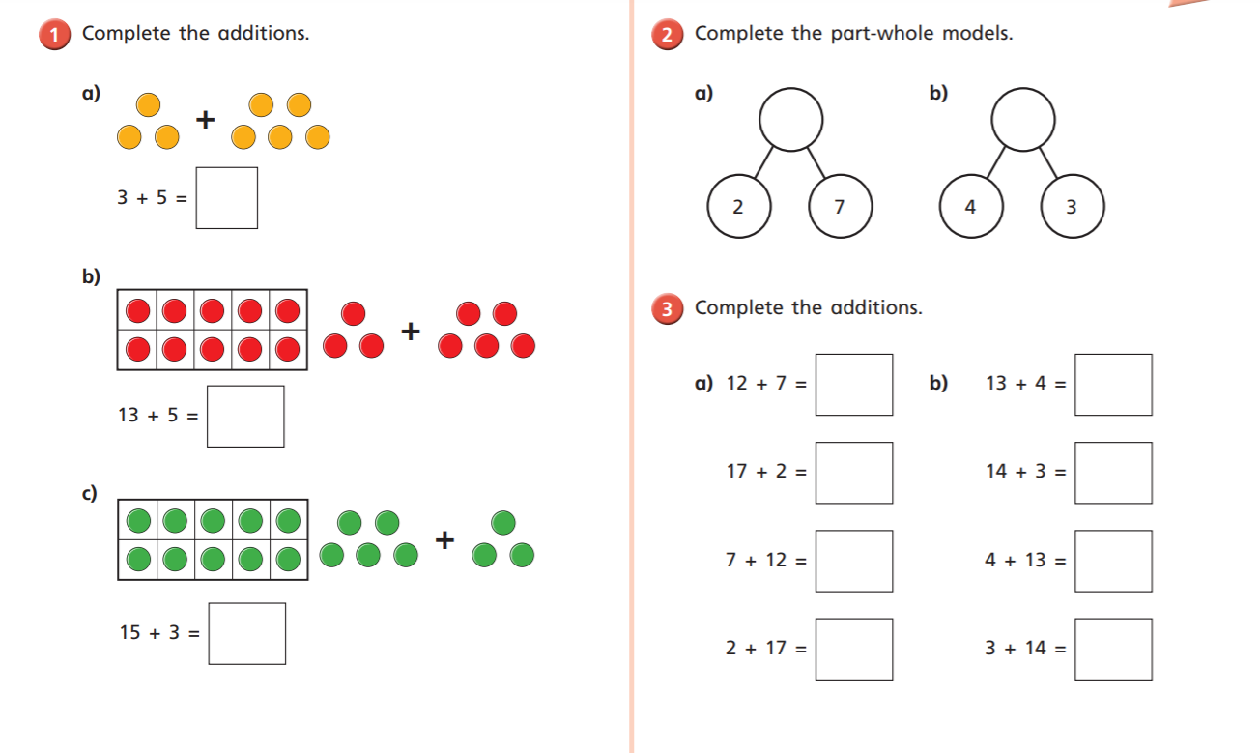

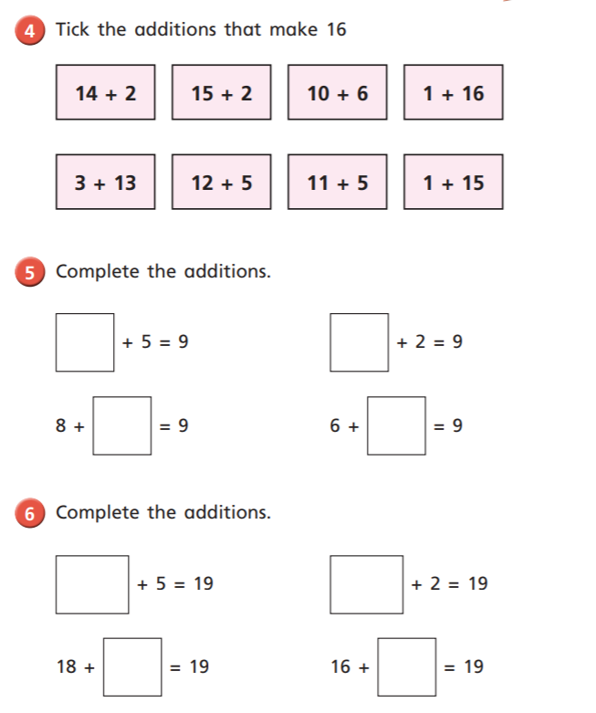

Reasoning and Problem Solving
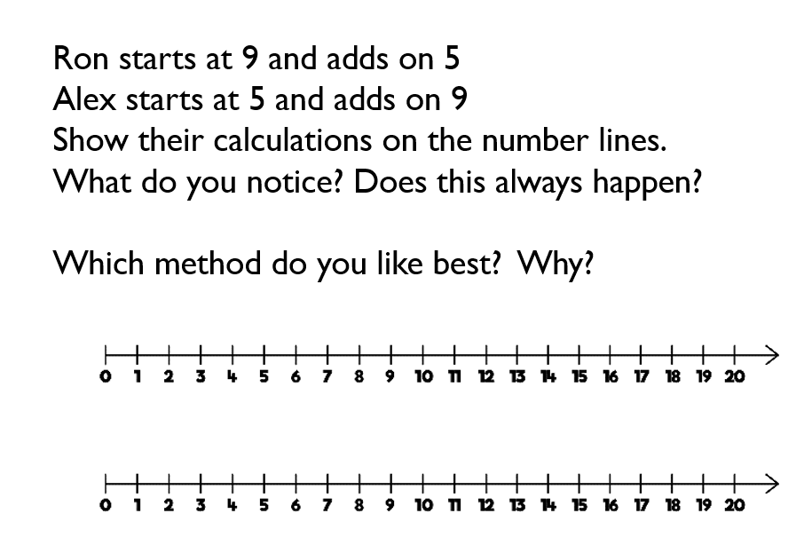

I noticed ……………………………………………………………………………………..
………………………………………………………………………………………………………
I think that this will always happen /not always happen
I know this because………………………………………………………………….
……………………………………………………………………………………………………..
I like ………………………………’s method because………………………
…………………………………………………………………………………………………..

